TO BE = být
I am = já jsem I am not = já nejsem
You are = ty jsi You aren’t = ty nejsi
He is = on je He isn’t = on není
She is = ona je She isn’t = ona není
It is = ono je It isn’t = ono není
We are = my jsme We aren’t = my nejsme
You are = vy jste You aren’t = vy nejste
They are = oni/ony/ona jsou They aren’t = oni/ony/ona nejsou

¨

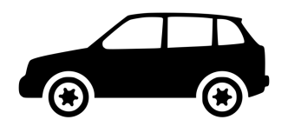
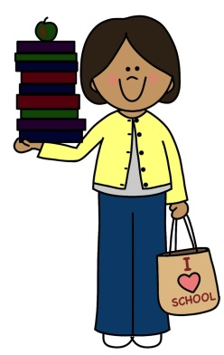
I am Kathy. It ______ a car.
I am a teacher. It ______ a plane.
I am not a cook. The car ______ black.
I am 27. I am not 33. The car ______ white.

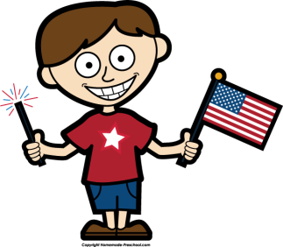
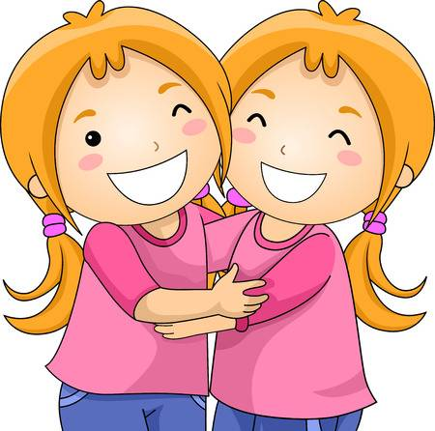
They _______ sisters. Sam _______ a boy.
They _______ twins. He _______ from the USA.
They ________ 13. He_______ from Japan.
They ________ 60.

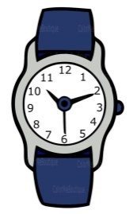
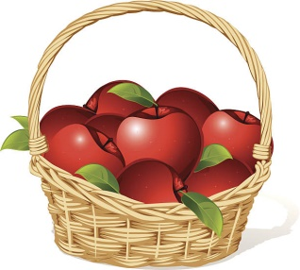
These ________ oranges. This ________ a box.
These ________ apples. This ________ a chair.
The apples ________ in the basket . This ________ a watch.

TO BE = být
I am = já jsem I am not = já nejsem
You are = ty jsi You aren’t = ty nejsi
He is = on je He isn’t = on není
She is = ona je She isn’t = ona není
It is = ono je It isn’t = ono není
We are = my jsme We aren’t = my nejsme
You are = vy jste You aren’t = vy nejste
They are = oni/ony/ona jsou They aren’t = oni/ony/ona nejsou

¨

I am Kathy. It ______ a car.
I am a teacher. It ______ a plane.
I am not a cook. The car ______ black.
I am 27. I am not 33. The car ______ white.

They _______ sisters. Sam _______ a boy.
They _______ twins. He _______ from the USA.
They ________ 13. He_______ from Japan.
They ________ 60.

These ________ oranges. This ________ a box.
These ________ apples. This ________ a chair.
The apples ________ in the basket . This ________ a watch.

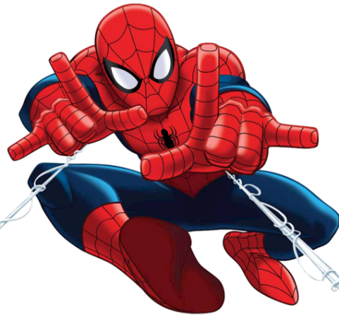
TO BE – otázky

- Is he Spiderman?
- Yes, he is.
- Is Spiderman a teacher?
- No, he isn’t. He is a superhero.
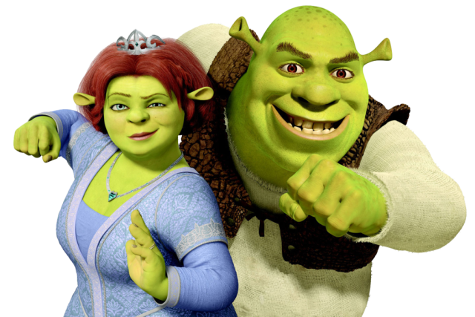
- ________ they Fiona and Shrek?
- __________________.
- ________ they pink?
- __________________. __________________.

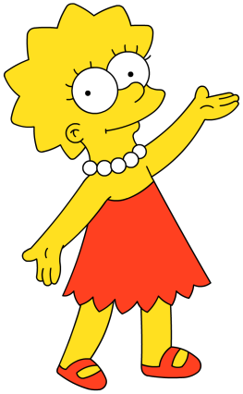
- ________ she Liza?
- __________________.
- ________ Liza yellow?
- __________________.
Draw a picture of yourself here!

- ________ you from the Czech Republic?
- __________________.
- ________ you a dragon?
- __________________. __________________.

TO BE – otázky

- Is he Spiderman?
- Yes, he is.
- Is Spiderman a teacher?
- No, he isn’t. He is a superhero.
- ________ they Fiona and Shrek?
- __________________.
- ________ they pink?
- __________________. __________________.

- ________ she Liza?
- __________________.
- ________ Liza yellow?
- __________________.
Draw a picture of yourself here!

- ________ you from the Czech Republic?
- __________________.
- ________ you a dragon?
- __________________. __________________.

