DATE | 19/3
SCIENCE
Was done during the lesson:
Review the water cycle from last week
Complete worksheet, write numbers to order how the cycle works. Then cut out the squares and make a game!
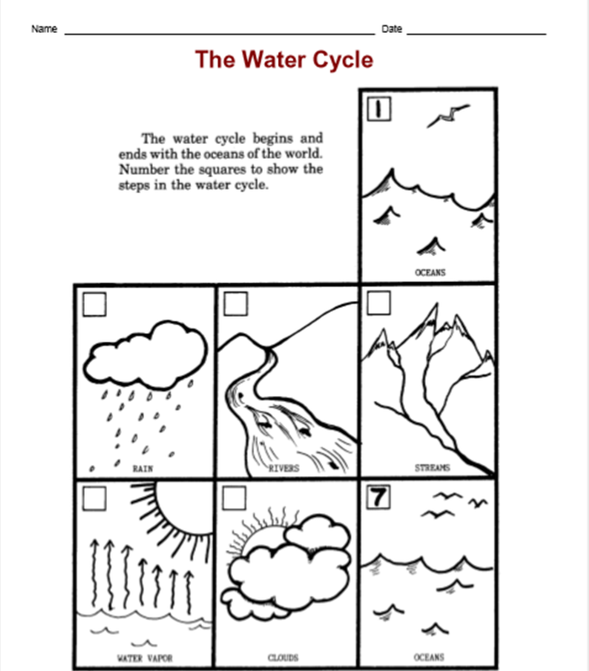

If the copy is not clear enough when enlarged, you can email at zoom.kimclil@gmail.com and I can send a pdf file
We have also a fun experiment to try at home! Teacher Geena and I made a video of how to do it and what you need.
https://www.youtube.com/watch?v=R_Mf3gYfYDM&t=1s
You can send out a video of it or a picture if you like!
Homework for:26/3
Try the experiment from the youtube link and send it as a video or picture to: zoom.kimclil@gmail.com

 | What to revise at home:

DATE | 16/3
ENGLISH
Was done during the lesson:
In your home find two of these toys: board game, doll, puzzle, robot, teddy bear (these are words from OW1SB P.98)
Who do you play these toys with? Write two sentences in a notebook/paper. Example: I do a puzzle with my mom. I play with the teddy bear with my sister.
Find your favorite toy- why is it your favorite toy?

Homework for:23/3
Use a smartphone or tablet and make a recording. Show the two toys you found plus your favorite toy. Say ‘This is…..My favorite toy is…’ send the video to zoom.kimclil@gmail.com. You can also try to send a voice recording if the video doesn’t work
 | What to revise at home:

