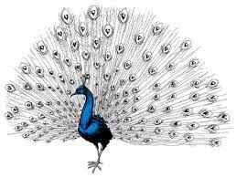



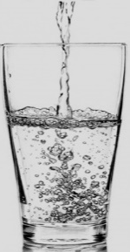




A | P | A | M | S
V | O | S | A | D
O | S | P | L | E
S | E | R | U | K
A | L | A | M | A
P | E | S | O | P
D | V | E | M | A



1 | 3 | 4 | 2 | 5 |  | 6 | 7 | 6 | 3 | 2
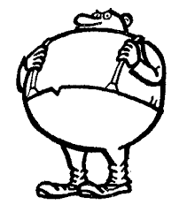

4 + 1 = Ý
10 – 4 = P
8 – 7 = V
4 + 3 = U
6 – 3 = E
0 + 2 = K
2 + 2 = L

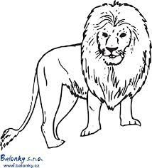

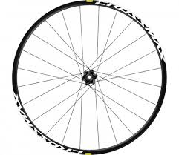
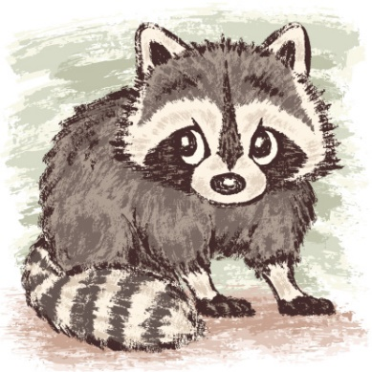

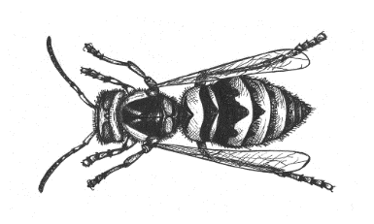
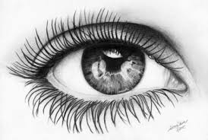

PEPALÉTÁJAKODATELPAVELJEDENAOSLOVI

EVAMÁVÁNAPSAJANAJEVESELÁ

