DATE | 18/03
ENGLISH
Was done during the lesson:
OW SB unit 5- Stories
Review- My house colors
https://www.education.com/game/this-is-my-house-level-aa/

(color the castle or make your own! Remember to include blue diamonds, red hearts, yellow stars, and green triangles. Count how many of each shape and write it on the paper)
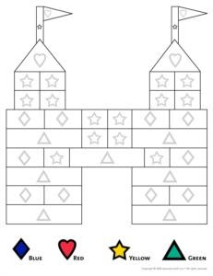
Homework for: Wednesday 25/03
Color and draw your house in your English notebook
What to revise at home:
Extra number castles, just count and maybe add more!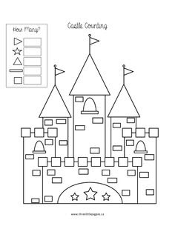

DATE | 17/03
Science
Was done during the lesson:
About me page 12
Me and my food
Listen to the song and sing it with food you like
https://youtu.be/frN3nvhIHUk

(Enlarge and print or draw your answers on a seperate piece of paper)
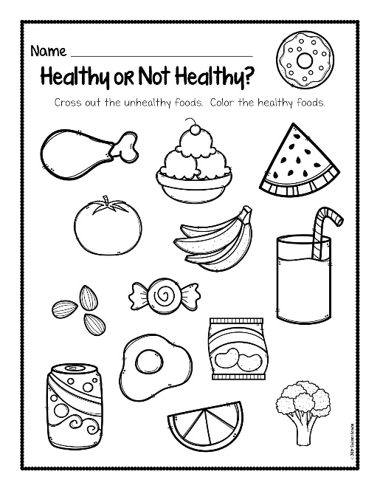
Feel free to add your favorite foods!
*bonus* circle all the red foods

Homework for: Tuesday 24/03
https://youtu.be/JqmJO7jt4pU
Answer the two questions in the video! You can
-write a comment under the video
or
-make your own video!
or
-write it on a piece of paper and show me when we come back
:)

What to revise at home:
For fun ! (fast) food matching game
http://www.kidsmathgamesonline.com/memory/food.html

