Put these words in the table, make the countable nouns plural!!
Lemon egg steak nut tea bean potato grape air saucepan milk sandwich time vegetable mushroom onion carrot time orange music sand coffee juice pork pasta rice tomato salt stone butter spaghetti packet tin glass sweet bowl sugar flour flower bus
Countable  Books  Apples | Uncountable  Bread  Cheese

- _________________________________________________________________________________
- _________________________________________________________________________________
- _________________________________________________________________________________
- _________________________________________________________________________________
- _________________________________________________________________________________
- _________________________________________________________________________________
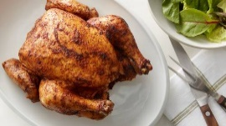
- _________________________________________________________________________________
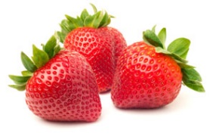

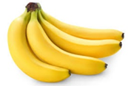
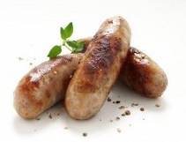
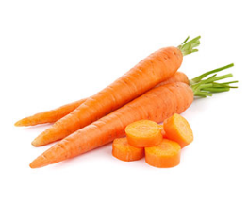
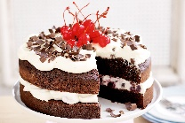
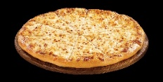
- _________________________________________________________________________________
8
7
6
5
4
3
2
1

